**Billing Anomaly Detection & Behavioral Insights**

A Machine Learning–Driven Approach for Smarter Billing

### Problem Statement

* Invoices are often generated late or with incorrect dates → interest miscalculations.
* Customers sometimes overpay or make duplicate payments.
* Leads to financial loss and customer trust issues.

### Scope

|  |  |
| --- | --- |
| ✅ Detect mismatches (invoice vs payment date). | ✅ Identify anomalies (overpayments, duplicates). |
| ✅ Profile customer behavior. | ✅ Provide insights (dashboards & alerts). |

### Solution Approach

* Rule-Based Checks
* Mark invoices late if payment >30 days.
* Flag overpayments (Payment > Invoice).
* ML & Behavioral Analysis
* Build customer profiles from history.
* Use LSTM models for payment pattern analysis.
* Flag out-of-pattern behavior.
* Visualization & Reporting
* Line charts, scatter plots, and bar charts for insights.

### 4. Sample Solution

**4.1 Sample Data Table**

|  |  |  |  |  |
| --- | --- | --- | --- | --- |
| Customer ID | Invoice Date | Payment Date | Invoice Amount | Payment Amount |
| 101 | 1 May 2025 | 1 Jun 2025 | 5,000 | 5,000 |
| 101 | 10 May 2025 | 15 Jun 2025 | 7,000 | 7,100 |
| 101 | 1 Jun 2025 | 5 Jul 2025 | 6,000 | 10,000 |
| 102 | 15 May 2025 | 16 Jun 2025 | 8,000 | 8,000 |
| 102 | 10 Jun 2025 | 8 Jul 2025 | 7,500 | 7,500 |
| 103 | 20 May 2025 | 1 Jul 2025 | 10,000 | 15,000 |
| 103 | 5 Jun 2025 | 6 Jul 2025 | 9,500 | 9,500 |
| 103 | 20 Jun 2025 | 25 Jul 2025 | 9,000 | 11,000 |

**4.2 Invoice vs Payment Trend (Explained)**

Invoice line is steady (₹5k–₹10k).

Payment line sometimes jumps (e.g., ₹15k paid).

➡️ Customers 101 & 103 overpaid invoices → possible errors or fraud.

**4.3 Invoice Age (Explained)**

Most payments within 30 days.

A few go 40+ days.

➡️ Highlights where late fees may apply.

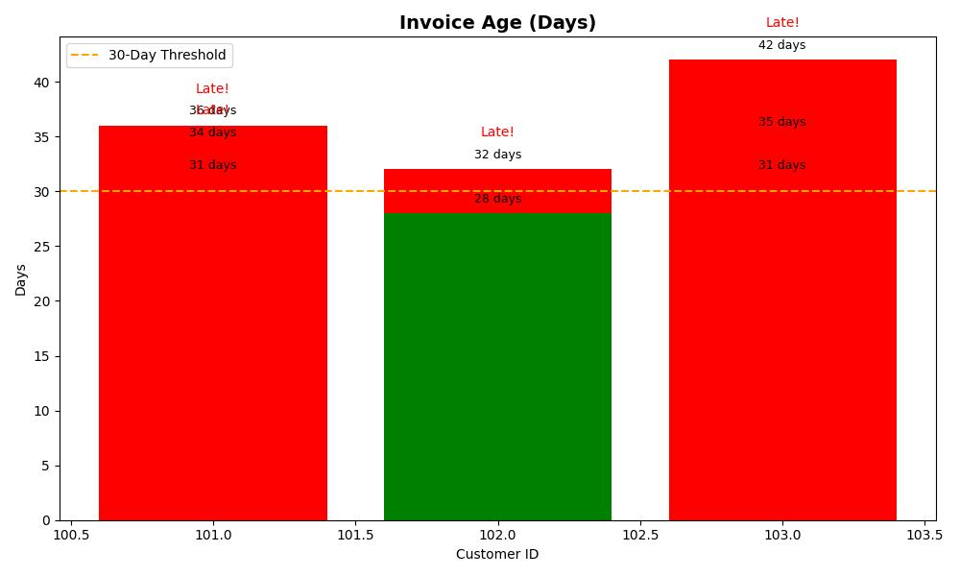

**4.4 Overpayment Detection (Explained)**   
Normally payments = invoice amount. Some payments exceed invoice. ➡️ Refund review or fraud check needed.

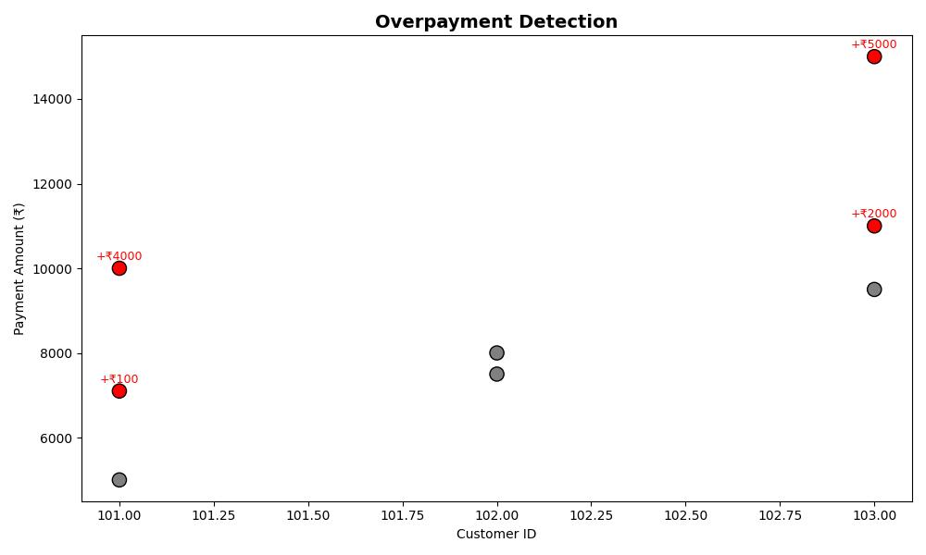

---

🔟 Next Steps

✅ Build rule system.

✅ Add ML anomaly detection.

✅ Real-time alerts.

✅ Integrate into ERP/finance tools.

---

Business Value

📉 Prevent losses from fraud & overpayments.

📊 Save time with automated checks.

🔐 Build trust with customers.

💰 Reduce costs by catching issues early